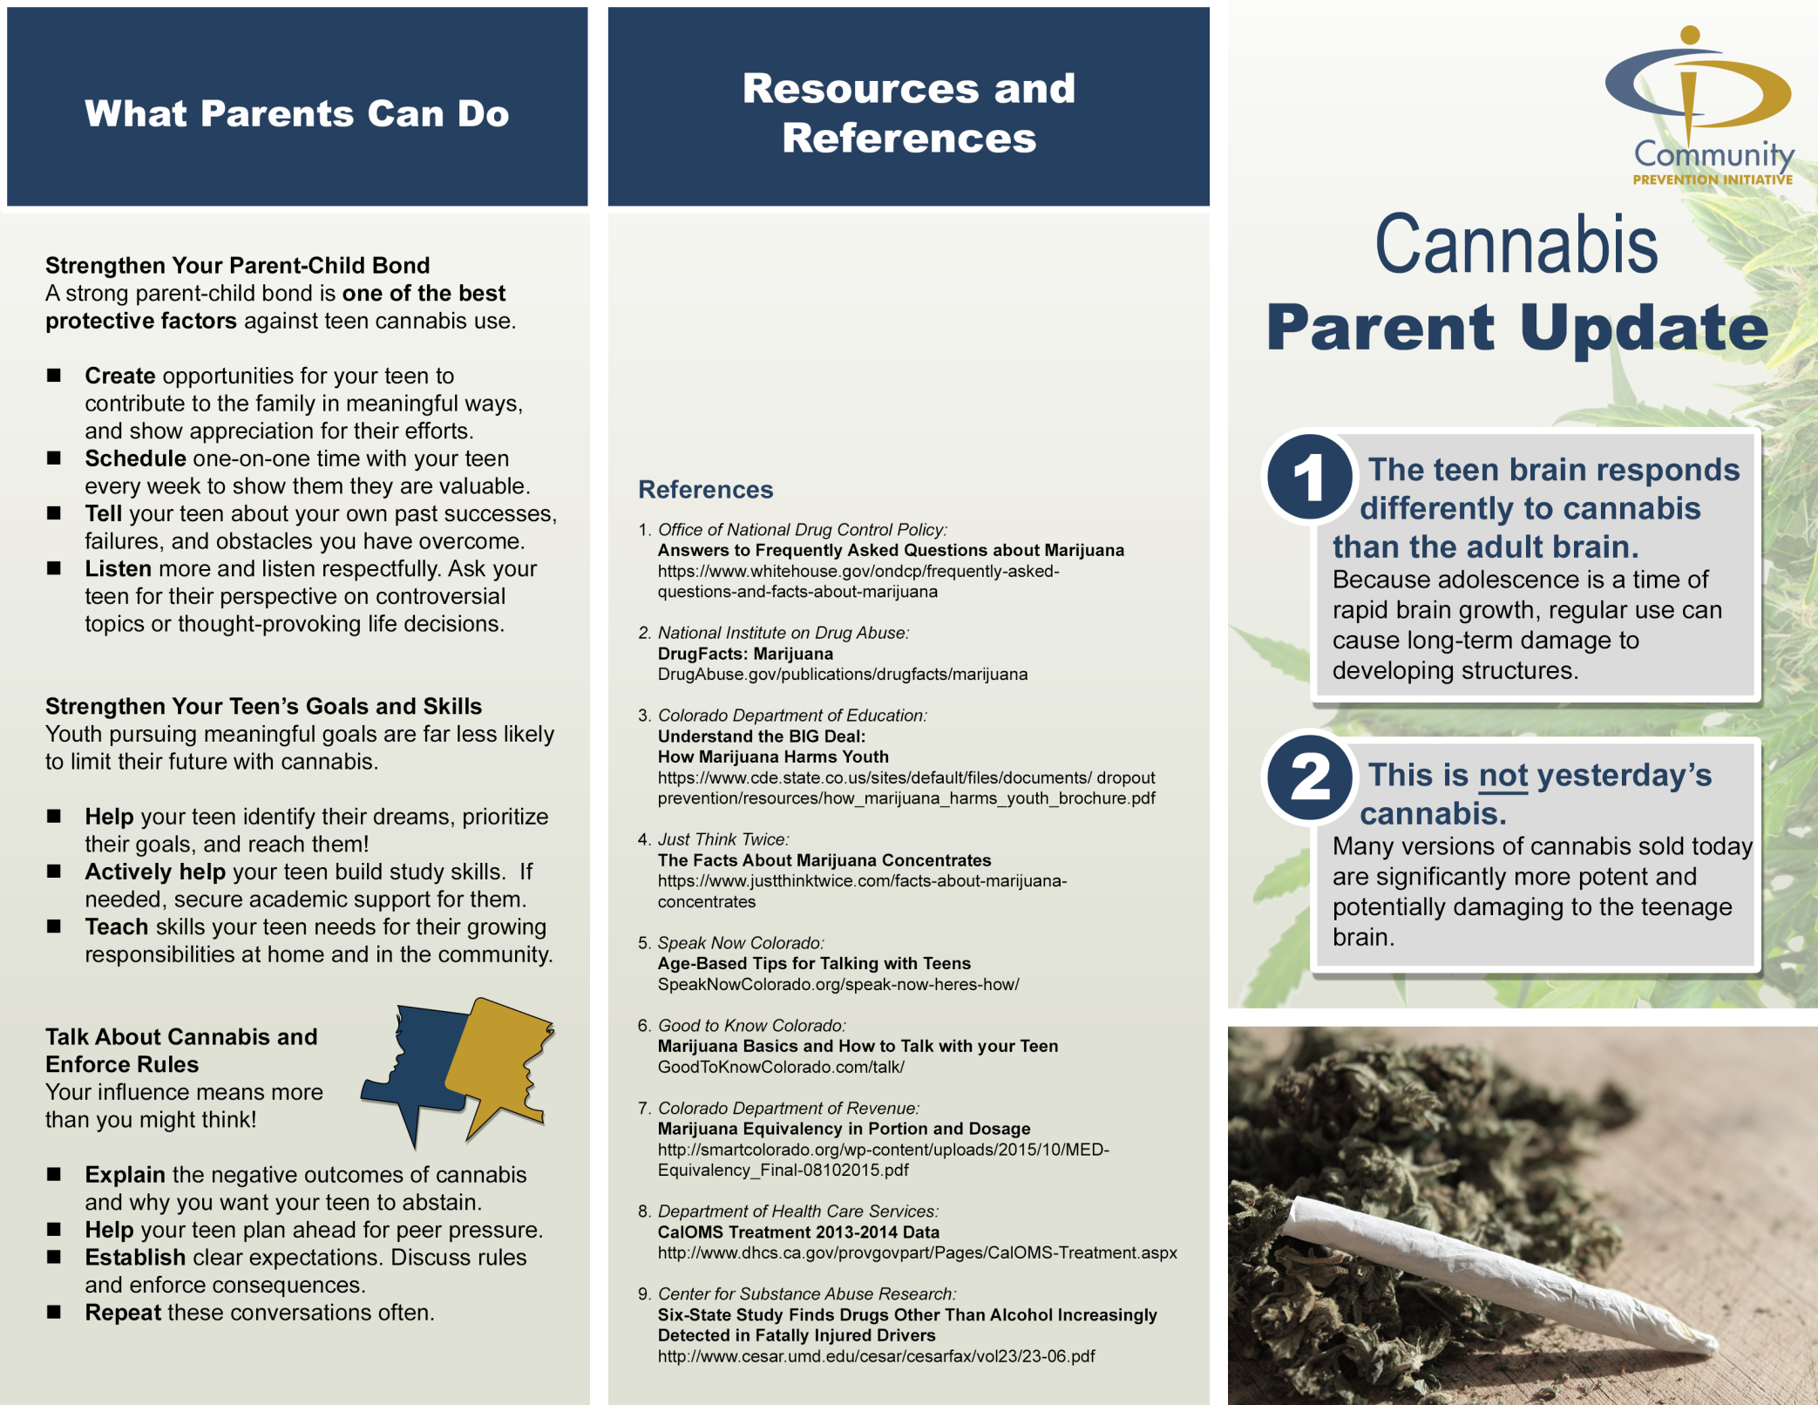

**Resources**

County Resource 1Phone NumberWebsiteCounty Resource 2Phone NumberWebsite

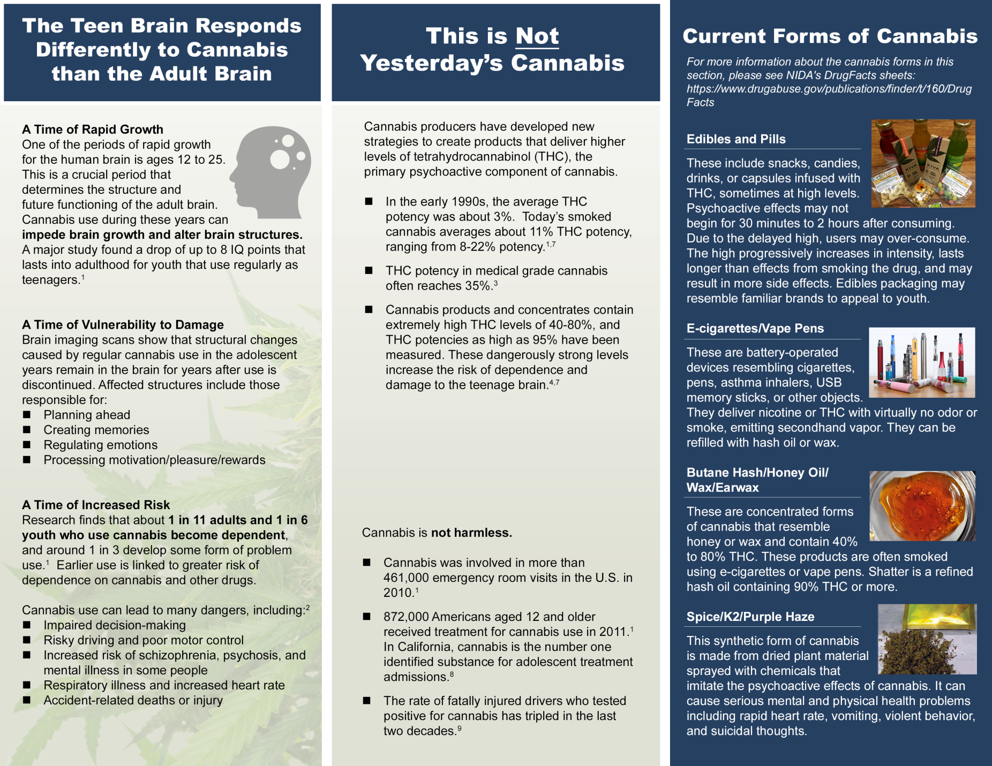

**Insert Relevant County Data Here**